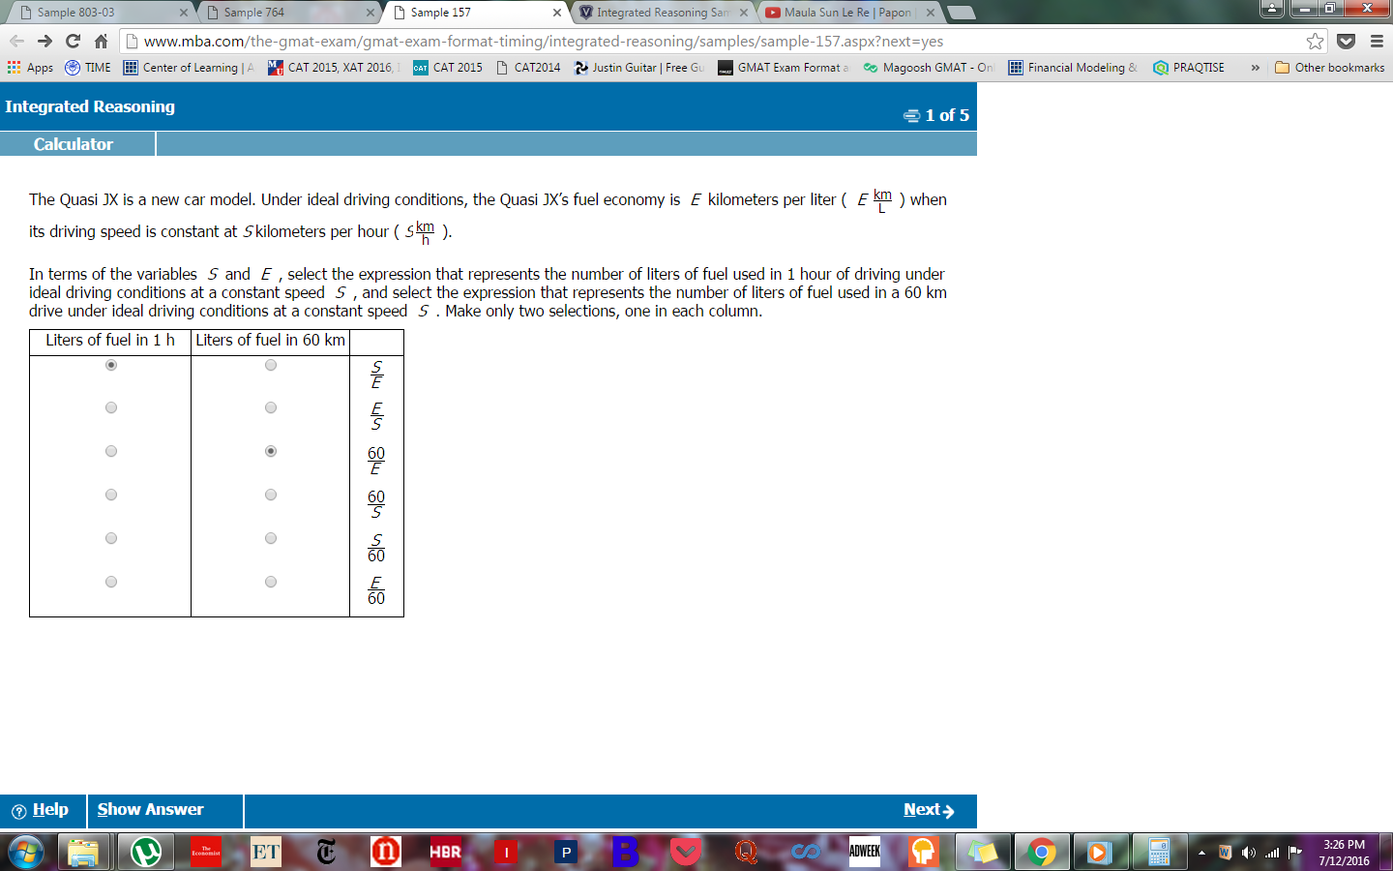

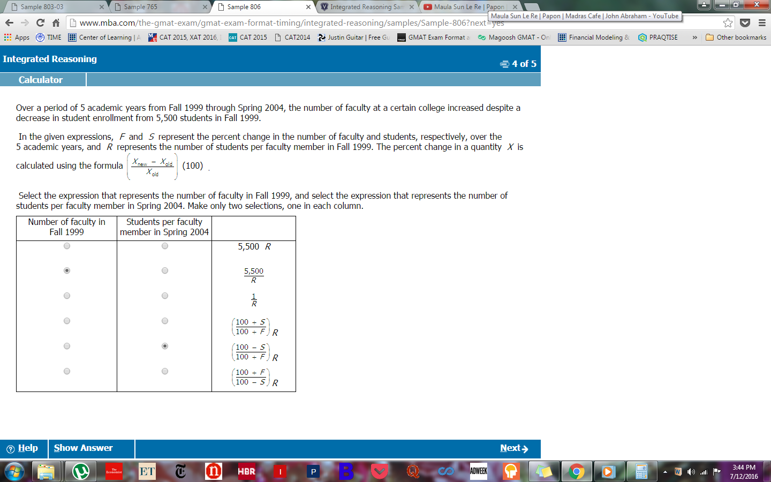

verbal

**IR q The events *A* and *B* are independent, and the probability that event *A* occurs is 0.4.**

https://jasper.kaptest.com/apps/delivery/media/hide-explanationsbutton.png

We're given a very short stimulus, with two pieces of data. One is that the probability of event *A*occurring is 0.4. The other is that events *A* and *B* are independent. This means that they are separate events whose outcomes do not influence one another—the probability of *A* occurring will be 0.4, no matter what happens to *B*.

This means that there are four possible ways that events *A* and *B* can combine. We'll jot them down, so that we can keep track of them all:

*A* and *B* both occur.

*A* occurs, but *B* does not.

*A* does not occur, but *B* does.

Neither *A* nor *B* occurs.

Now, let's add some math to this analysis. If the probability that *A* occurs is 0.4, the probability that*A* doesn't occur is 0.6. We don't know the probability of *B* occurring, so the best we can do is call it the variable *b*. The probability that event *B* does not occur would be 1 –*b*. Let's translate our list of possible outcomes into math, keeping in mind that we must multiply together the individual probabilities when we wish to calculate the probability of more than one independent event occurring:

*A* and *B* both occur = 0.4*b*

*A* occurs, but *B* does not = 0.4(1 –*b*)

*A* does not occur, but *B* does = 0.6*b*

Neither *A* nor *B* occurs = 0.6(1 –*b*)

**In the table below, choose the two numbers that are consistent with the information that is given. In the first column, select the row that shows the probability that at least one of the events *A* and *B* occurs, and in the second column, select the row that shows the probability that event *B* occurs**.

|  |  |  |
| --- | --- | --- |
| **Probability that at least one of the events A and B occurs** | **Probability that event B occurs** |  |
|  |  | 0.10 |
|  |  | 0.25 |
|  |  | 0.50 |
|  |  | 0.55 |
|  |  | 0.60 |
|  |  | 0.80 |

https://jasper.kaptest.com/apps/delivery/media/hide-explanationsbutton.png

https://jasper.kaptest.com/apps/delivery/media/info_icon.png**Question Statistics:**

Test-taker response data for this question is being updated.

We're asked to find the probability that event *B* occurs, such that one of the answer choices reflects the probability of either *A* or *B* occurring—in other words, any outcome other than neither *A* nor *B* occurring.

Since the only outcome we want to exclude is neither *A* nor *B* occurring (see stimulus explanation, above), we can create an equation by subtracting that one undesired outcome from the total of 1:

Probability that at least one of *A* and *B* occurs = 1 – [0.6(1 –*b*)]

= 1 – (0.6 – 0.6*b*)

= 1 – 0.6 + 0.6*b*

= 0.4 + 0.6*b*

(Note that there are two other ways to set this equation up. We could add the three desired outcomes together to yield 0.4*b* + 0.4(1 –*b*) + 0.6*b*. Alternately, we could add the probabilities of *A* and *B*, then subtract the double-counted outcome of both occurring, yielding 0.4 + *b*– 0.4*b*. On Test Day, go with whichever approach feels most straightforward—all of these approaches simplify to 0.4 + 0.6*b*.)

Now let's consider the possible values given in the answer choice list. Thinking about the situation logically, we can determine that the probability that *B* occurs must be less than the probability that at least one of *A* or *B* occurs. We will therefore begin by plugging in the smaller values from our list for the variable *b* in the equation we set up above. If one of these values for *b* results in a probability for "at least one of the events *A*or *B*" that matches one of the given choices, we know we have found the correct answer.

If *b* were equal to 0.1, then the probability that at least one of *A* and *B* occurs would equal 0.46, which is not an answer choice. This strongly suggests that 0.25 is the probability that *B*occurs, since it is the only other small answer choice. A larger probability might be possible, since the probability of at least one of*A* and *B* might be as high as 0.8, but plugging in *b* = 0.25 is a reasonable next step.

We'll substitute *b* = 0.25 into our equation and see whether it produces one of the other answer choices. If it does, that pair will be correct. If it doesn't, we'll try a different value for *b*. Plugging *b* = 0.25 into our equation yields:

Probability that at least one of *A* and *B* occurs = 0.4 + 0.6(0.25)

= 0.4 + 0.15

= 0.55

This possible value matches one of the answer choices, so we have found the values that satisfy the conditions. Now, as always with Two-Part Analysis questions, we must be careful to select the correct answer choices in the appropriate columns; it would be a shame to do all the math correctly but lose the points for this question by mixing up the columns.

The correct response for the "probability that at least one of the events *A* and *B* occurs" is **0.55**; the correct response for the "probability that event *B* occurs" is **0.25**.